**IRE 206: Microprocessor and Interfacing IoT Lab**

**Experiment-6:** Interfacing of Bluetooth Module with Microcontroller and Brightness Control of LED.

**Interfacing HC-05 bluethooth module:**

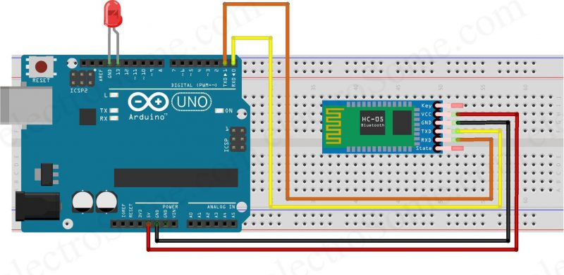

**Code-1: Turning on and off LED from android app.**

int red=13;

char press;

void setup() {

Serial.begin(9600); //bot rate of serial monitor as well as the bluetooth module

pinMode(red, OUTPUT);

}

void loop() {

if(Serial.available()!=0)

{

  switch=Serial.read();

}

if(press=='1')

{

  Serial.println("on");

  digitalWrite(red, HIGH);

}

if(press=='0')

{

 Serial.println("off");

  digitalWrite(red, LOW);

}

}

**Code-2: Controlling brightness**

const int ledPin = 9; // Connect the LED to pin 9

int brightness = 0; // Initial brightness value

void setup() {

Serial.begin(9600); // Start serial communication

pinMode(ledPin, OUTPUT); // Set the LED pin as an output

}

void loop() {

if (Serial.available() > 0) {

char command = Serial.read(); // Read the command from Serial Monitor

// Increase brightness if 'u' is received

if (command == 'u' && brightness < 255) {

brightness += 10;

}

// Decrease brightness if 'd' is received

else if (command == 'd' && brightness > 0) {

brightness -= 10;

}

analogWrite(ledPin, brightness); // Set the LED brightness

Serial.print("Brightness: ");

Serial.println(brightness); // Print the current brightness to Serial Monitor

}

}